12/19/2021
OOAD-PROJECT
SEF-19A
Submitted To: Mam Amina Mirza
Group:02
DANIYAL HAIDER (BSEF19A019)
NIMRA ABID (BSEF19A022)

CREDIT CARD FRAUD DETECTION SYSTEM

Table of Contents
Vision: 5
Elaborated view: 6
Introduction: 6
Significance: 6
Domain Rules: 7
User Rules: 7
Manager Rules: 7
Admin Rules: 7
Feature List: 7
Security: 7
Easy to access: 7
Predictive Analysis: 8
Outlier Model: 8
Custom Rule Management: 8
User friendly: 8
Risk Analysis: 8
Geographic Location: 8
Transaction Amount: 8
Credentials: 9
Security Page: 9
Payment Defaulter: 9
Business Level Use Case Diagram: 9
Analysis Level Use Case Diagram: 11
System Requirements: 12
Feasibility: 12
Technical: 12
Timeline: 12
Financial: 12
Major Requirements (FURPS+) 13
Functionality 13
Usability 13
Reliability 13
Performance 13
Supportability 13
Supplementary Specification: 14
Actors: 14
Primary Actor: 14
Secondary Actor: 14
Goals: 14
Stakeholders: 14
Casual Type of Use Cases: 15
Use Case 1 15
Diagram: 15
Description: 15
Use Case 2: 16
Diagram: 16
Description: 16
Use Case 3: 17
Diagram: 17
Description: 17
Use Case 4: 18
Diagram: 18
Description: 18
Use Case 5: 19
Diagram: 19
Description: 19
Use Case 6: 20
Diagram: 20
Description: 20
Activity Diagram: 21
Swimlane Activity Diagram: 22
22
Package Diagrams: 23
1. Credit Card Fraud System: 23
2. Home Package Diagram: 24
3. Login Package Diagram: 24
4. Registration Package Diagram: 25
5. Authentication Package Diagram: 26
6. Transaction Package Diagram: 26
State Chart Diagram: 27
Design Class Diagram: 28
Architecture Level: 28
Business Level: 29
Sequence Diagram (SD): 30
Architecture Level: 30
Business Level: 31
System Sequence Diagram (SSD): 32
1-SSD for use case Home and actor User: 32
2-SSD for use case Home and actor Manager: 32
3-SSD for use case Registration and actor User: 33
4-SSD for use case Registration and actor Manager: 33
5-SSD for use case Login and actor User: 34
6-SSD for use case Authentication and actor Manager: 34
7-SSD for use case Transaction and actor User: 35
8-SSD for use case Transaction and actor Manager: 35
9-SSD for use case Transaction and actor Admin: 36
10-SSD for use case Security and actor User: 36
11-SSD for use case Security and actor Manager: 37
Collaboration Diagram 38
Architecture Level: 38
Business Level: 39
Risks 40
1. Friendly fraud: 40
2. Bust-out fraud: 40
3. Cloning: 40
4. Malware: 40
5. Skimming: 40
6. Phishing: 41
Risks Mitigation 41
1) Artificial neural networks 41
2) Analytics 41
3) Alerts 41
4) Customer-level views 42
Prototype (Wireframe) 43
Home Page: 43
Registration Page: 44
Login Page: 45
About Us: 46
System Page: 47
Use-Case Contracts: 48
1. Operation: EnterHome(int choice) 48
2. Operation: Register() 48
3. Operation: Details(string name, string bankname , int CVC, int PhoneNumber, string email, decimal CardNumber) 48
4. Operation: userDetails(Details user) 48
5. Operation: cardDetails(Details card) 49
Cross Reference: 49
6. Operation: login(string password, string username,string email) 49
7. Operation: credentialsAuthentication(int choice) 49
8. Operation: AccessTransaction(Details user, Details card) 49
9. Operation:TransactionDetails() 50
10. Operation:bankVerification(Details Userdetails, Details Carddetails , TransactionDetails details) 50
11. Operation: securityCheck(string []questions) 50
12. Operation:Transaction Status(bool check) 51
Github Repository Link: 51
https://github.com/Nimraahh/Credit-Card-Fraud-Detection-System 51
Glossary: 51
Predictive Analysis: Pre-analysis (before fraud) 51

Vision:

An online platform where users can register themselves perform transactions with security and any kind of credit card will be detected and dealt with accordingly.
In this world, many credit card frauds happen, and people lose their money in a moment. Our system enables easy and secure access to accounts where people can register their details along with credit card information.
Users can login into the portal provide their details which will be verified via bank. In case of any wrong information, the user will be taken into a security page, through which he can provide security details via which he can re-access his account or else it will be blocked.

Elaborated view:

Introduction:
We are designing a Credit Card Fraud Detection System.
Our system detects the location of geography for verification. If it notices any abnormal pattern, then the user needs to go through the verification method again. Our System is capable to store every user’s previous transaction data. By using this information, it measures the normal user behavior models for separate users. In case of any detection of strange activity, this detection will give alerts and block the operator once he made three unacceptable attempts.
Without any proper Credit Card Fraud Detection System, credit cards can be cloned, password patterns can be decrypted thus we can say that anyone can hack into it and perform transactions from the card holder’s account. Our system will be an effective solution for all such problems.
- It will increase the security of transactions perfumed via credit cards.
- This system will provide a sense of ease to user’s that their money is protected
- Records of Transaction behavior are kept so that any anomaly can be detected immediately.
- The system can be handled easily as it provides a user-friendly environment.

Significance:
For individuals, credit cards are an important part of everyday life. Whether purchasing gas and groceries or reserving a hotel and rental car for an upcoming vacation, credit cards represent a convenient and secure form of payment for consumers. Benefits ranging from damage protection on purchases to the ease of disputing suspicious charges or fraudulent activity make credit cards an attractive form of payment. That is why Credit Card Fraud must be detected then and there so that cardholder does not lose its access or bear any financial loss.

Domain Rules:

User Rules:
- The user is required to register himself into the system
- The user is required to provide his correct personal details for proper verification
- The user is required to give correct credit card details. In case of false information, proper action can be taken.
- The user is required to inform any anomaly he detects to the bank so that fraud possibilities are cornered to a minimal percentage.

Manager Rules:
- The manager is in direct contact with the User.
- The manager has access to the registration details of the user
- The manager is responsible to register users into the database.
- Manager generates a status report of the activity of the user
- The manager provides this report to Admin.

Admin Rules:
- Admin does not deal with users directly but via Manager,
- Admin receives the status report generated by the Manager.
- Admin deals with the phenomenon of decisions regarding user being defaulter or card being blocked for suspicious activities.

Feature List:

Security:
Our system is as secure as it can get. After proper validations and checks, the user is allowed to access his account and perform transactions. Fraud is analyzed by the bank and dealt with immediately. Users can also contact the bank in case of any strange activity notification they might get on their device

Easy to access:
Our system is quite easy to access. The user just needs to open the portal on Google and enter his credentials to login into the system or register himself if he has not already, all actions are performed under strict restrictions and checks so that no anomaly can occur on either user or admin end.

Predictive Analysis:
Our system observes the patterns of users’ usual transactions and stores them in the database, it also detects the geographic location of the user’s usual transaction area.
In case of any anomaly, proper actions are taken.

Outlier Model:
Our system also works on the outlier model. In case of any linear discrepancy in the transaction graph of the user, the bank verifies it from the user.

Custom Rule Management:
As some banks have rules that their credit cards will not work in foreign countries. Our system is aware of the policies of those banks and deals with them accordingly.

User friendly:
Our system is user-friendly. In case of system error or false fraud, the detection user is directed to the security page and answer some verification questions then he is allowed to perform that transaction which caused a red alert.

Risk Analysis:

Geographic Location:
User’s credit card can be cloned and used in the same geographic location, or his account can be used for huge transactions in the same area he lives in and thus no geographic anomaly can be detected in this case

Transaction Amount:
It might be possible that the thief performs the usual amount of transactions from the user’s account more than one time so that he cannot be detected. This is not dealt with in our system.

Credentials:
It might be possible that the user’s credentials are in hold of the thief, and he performs transactions without any unusual pattern and get away with it unless the user notifies the bank.

Security Page:
In case of invalid credentials or an unusual pattern of the transaction, the amount used is taken to a 3rd party security page. It might be possible that the user’s personal details are already exposed to the thief and thus he gets away.

Payment Defaulter:
This might be possible that the user on their own has not cleared payments for many months and his card gets blocked and the security team is also unable to trace him. Our system does not help in this case.

Business Level Use Case Diagram:

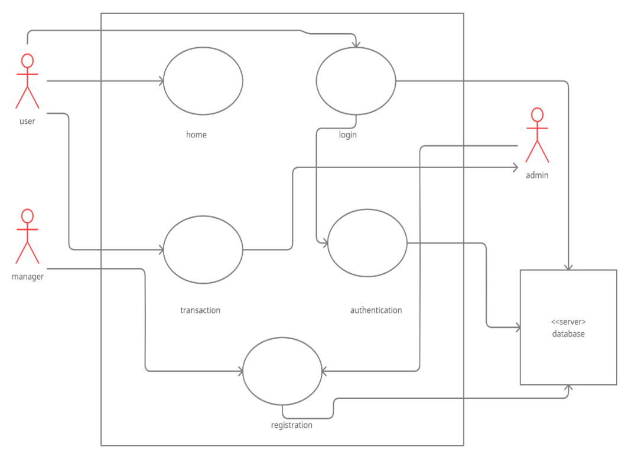

Analysis Level Use Case Diagram:

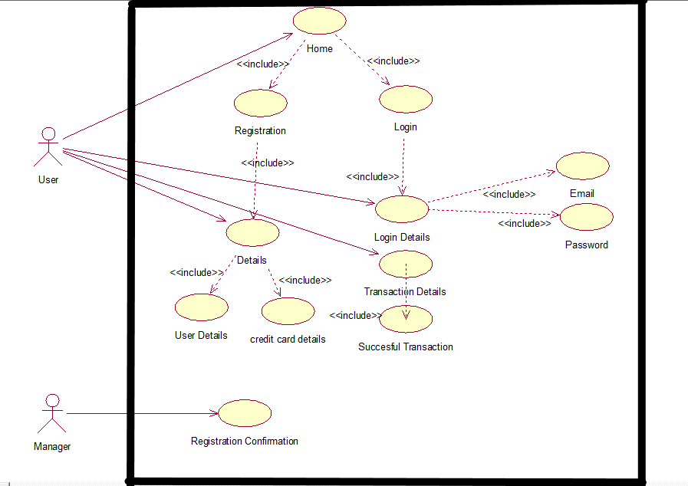

System Requirements:

Following are the major requirements in our system.
- Our System checks whether the name provided by the user and the name of the cardholder in the system matches or not.
- Our System checks whether the card number provided by the user and the card number of that particular cardholder in the system matches.
- Our System checks whether the CVC provided by the user and the Card verification code of that particular card in the system matches or not.
- Our System checks whether the date of Expiry provided by the user and the date of Expiry of that particular card in the system matches.
- Our system observes the last 3 usual payment patterns of users if the next transaction varies from that pattern it takes the user to the security page.
- Our system also asks the country of the user via his I.P (Internet Protocol) it checks if the user has performed any past transaction from that country or not.

Feasibility:

Technical:
Our system uses modern technology and developers are experienced and fully devoted to their goals. Our system is checked for any updates and malfunctions every day thus the possibility of bugs and system faults are decreased.

Timeline:
We work under the principle of the Rational Unified Process Model (RUPM). So our system is designed in a quite simple manner and easy to use with short deadlines and our fraud detection algorithms work very sharply that it can detect fraud in less time thus it is a well-suited system for fraud detections of the credit card.

Financial:
Our system is free for users to operate. More users use our system more profit to the developing team and company thus a bigger budget for updates and corrections in the system.

Major Requirements (FURPS+)

Functionality
- The system will be thoroughly tested.
- The quality of the system will be assured before deployment to avoid any issues in future
- The development team will be capable of modification at any stage later on in case of system faults or third-party security page false alarms.
- The security of the system will be given priority by the development team. This is the most important aspect as data of clients such as credit card details are provided within the system.

Usability
- Avoid entering fake credit card details on purpose
- Ease of use access is given priority.
- The system is easy to handle so that anyone can use it
- Avoid entering the password wrong more than 3 times.

Reliability
The system must not crash while in use, even if it does all credit card details provided by the user at that time or any other detail is reset on its own so thus the security of the system is top-notch.
- In case of system failures or updates, the user will be notified of a sorry message for the inconvenience.
- Developers do thorough testing before giving the system a green light to go live. It is ensured that the admin end, as well as the user end, is working just fine.

Performance
- The system is free of bugs thus transactions are performed in a blink of an eye without any hustle.
- Credit cards of all banks are acceptable
- The database is well managed by the manager and fraud detections algorithms work on the backend of the system.

Supportability
- The system is adaptable to the credit card of any bank. It supports a user-friendly environment in every way
The system does not follow the waterfall approach thus any kind of modification in the system can happen at any stage.

Supplementary Specification:

In addition to FURPS, our system requires a special specification that is validation from the bank and manager storing the data in the database.
1-All banks are cooperating on the backend, the user might enter credit card details of any bank thus that bank is responsible for validation and verification of that user.
2-Manager is responsible for registering users into the database. So, a special database is required where the user is registered and from where he is authenticated.
3- Cost is needed to maintain the system throughout thus funds are also required by the system.

Actors:
  - User
  - Manager
  - Admin

Primary Actor:
- User
- Manager

Secondary Actor:
- Admin

Goals:

- Fraud Free system to be provided to users.
- Responsive system to be provided to users
- To save users from a heavy loss.
- Easy transactions facility.

Stakeholders:
- User
- Manager
- Admin
- Bank

Casual Type of Use Cases:

Use Case 1: Home
Actors: User, Manager

Diagram:
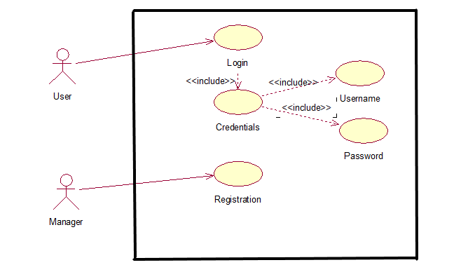

Description:
The user accesses the home screen to either log in or register himself into the database to access the system.
The home screen enables user to view 2 options which are login and registration. He clicks on either of them to view the respective Page. Manager enters the registration of user into the database

Use Case 2: Registration
Actors: User, Manager

Diagram:
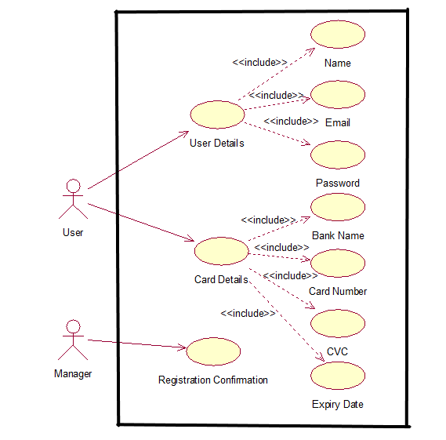

Description:
User accesses Registration page via the home screen. The user wants to register itself Into the database.
Via Registration user provides his details into the system and validates himself into the database. All details are verified from the bank and then the user proceeds into further tasks.

Use Case 3: Authentication
Actor: Manager

Diagram:
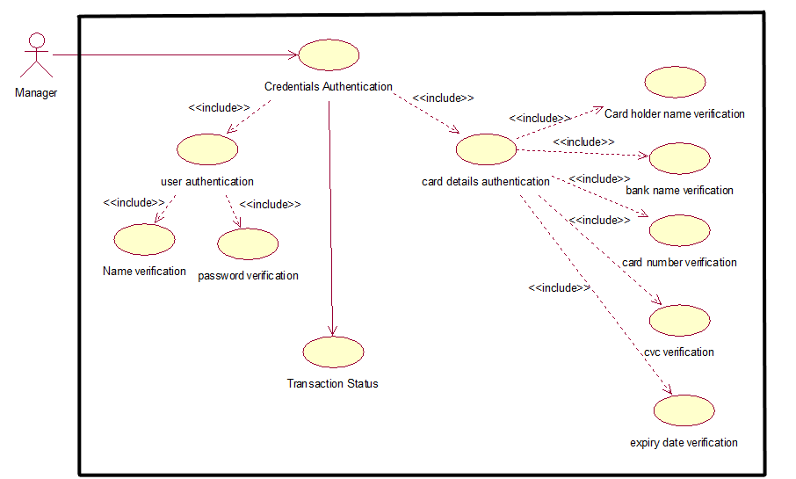

Description:
The manager authorizes the details provided by the user. Both user details and credit card details are verified for a successful transaction.
The manager then can generate a status report to show to the admin.

Use Case 4: Transaction
Actor: User, Manager, Admin

Diagram:
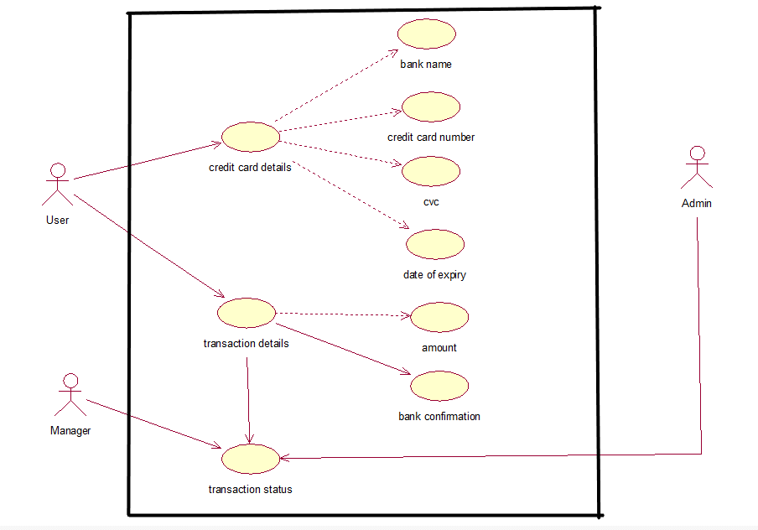

Description:
The user provides his credit card details which include bank name, credit card number, CVC, date of expiry of credit card for transaction purposes.
The user also provides transaction detail such as the amount to be transferred which is then observed by the system for any unusual situation.
Manager Receives transaction status as if details are correct and verified then the transaction is performed thus no fraud.

Use Case 5: Login
Actor: User

Diagram:
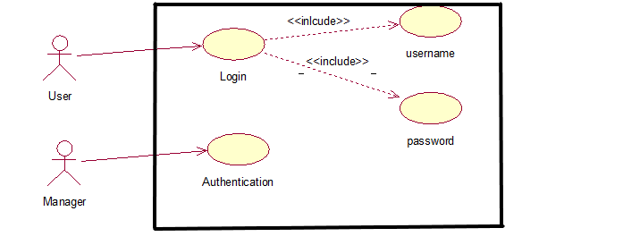

Description:
The login page is accessed via Home Screen, user can log in To the system via this login method.
The user gives his personal username and password to log in to the system to enter details of him, credit card, and amount of transaction to proceed further.
The system matches the details via the details which the manager has stored in the database at the time of registration and authenticates a user to proceed further.

Use Case 6: Security
Actor: User

Diagram:

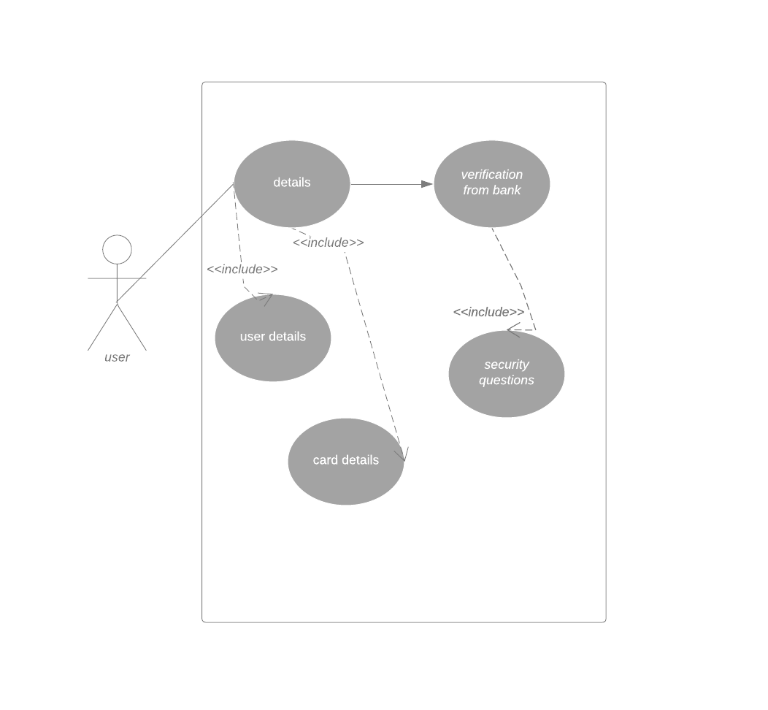

Description:
User enters his details and credit card details. If he keeps on entering wrong details 3 times, then he will be directed to a Security Page where he will be asked questions and will get verified. If failed to do so, the card gets block.

Activity Diagram:

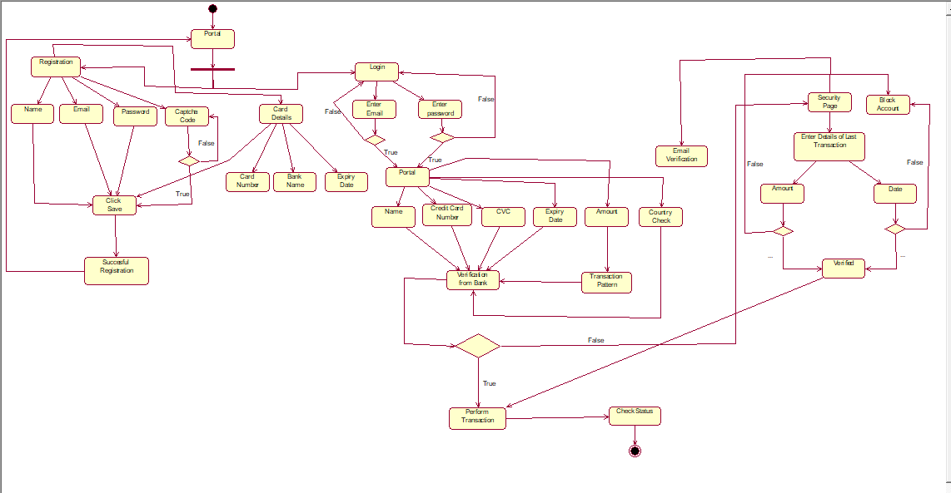

Swimlane Activity Diagram:

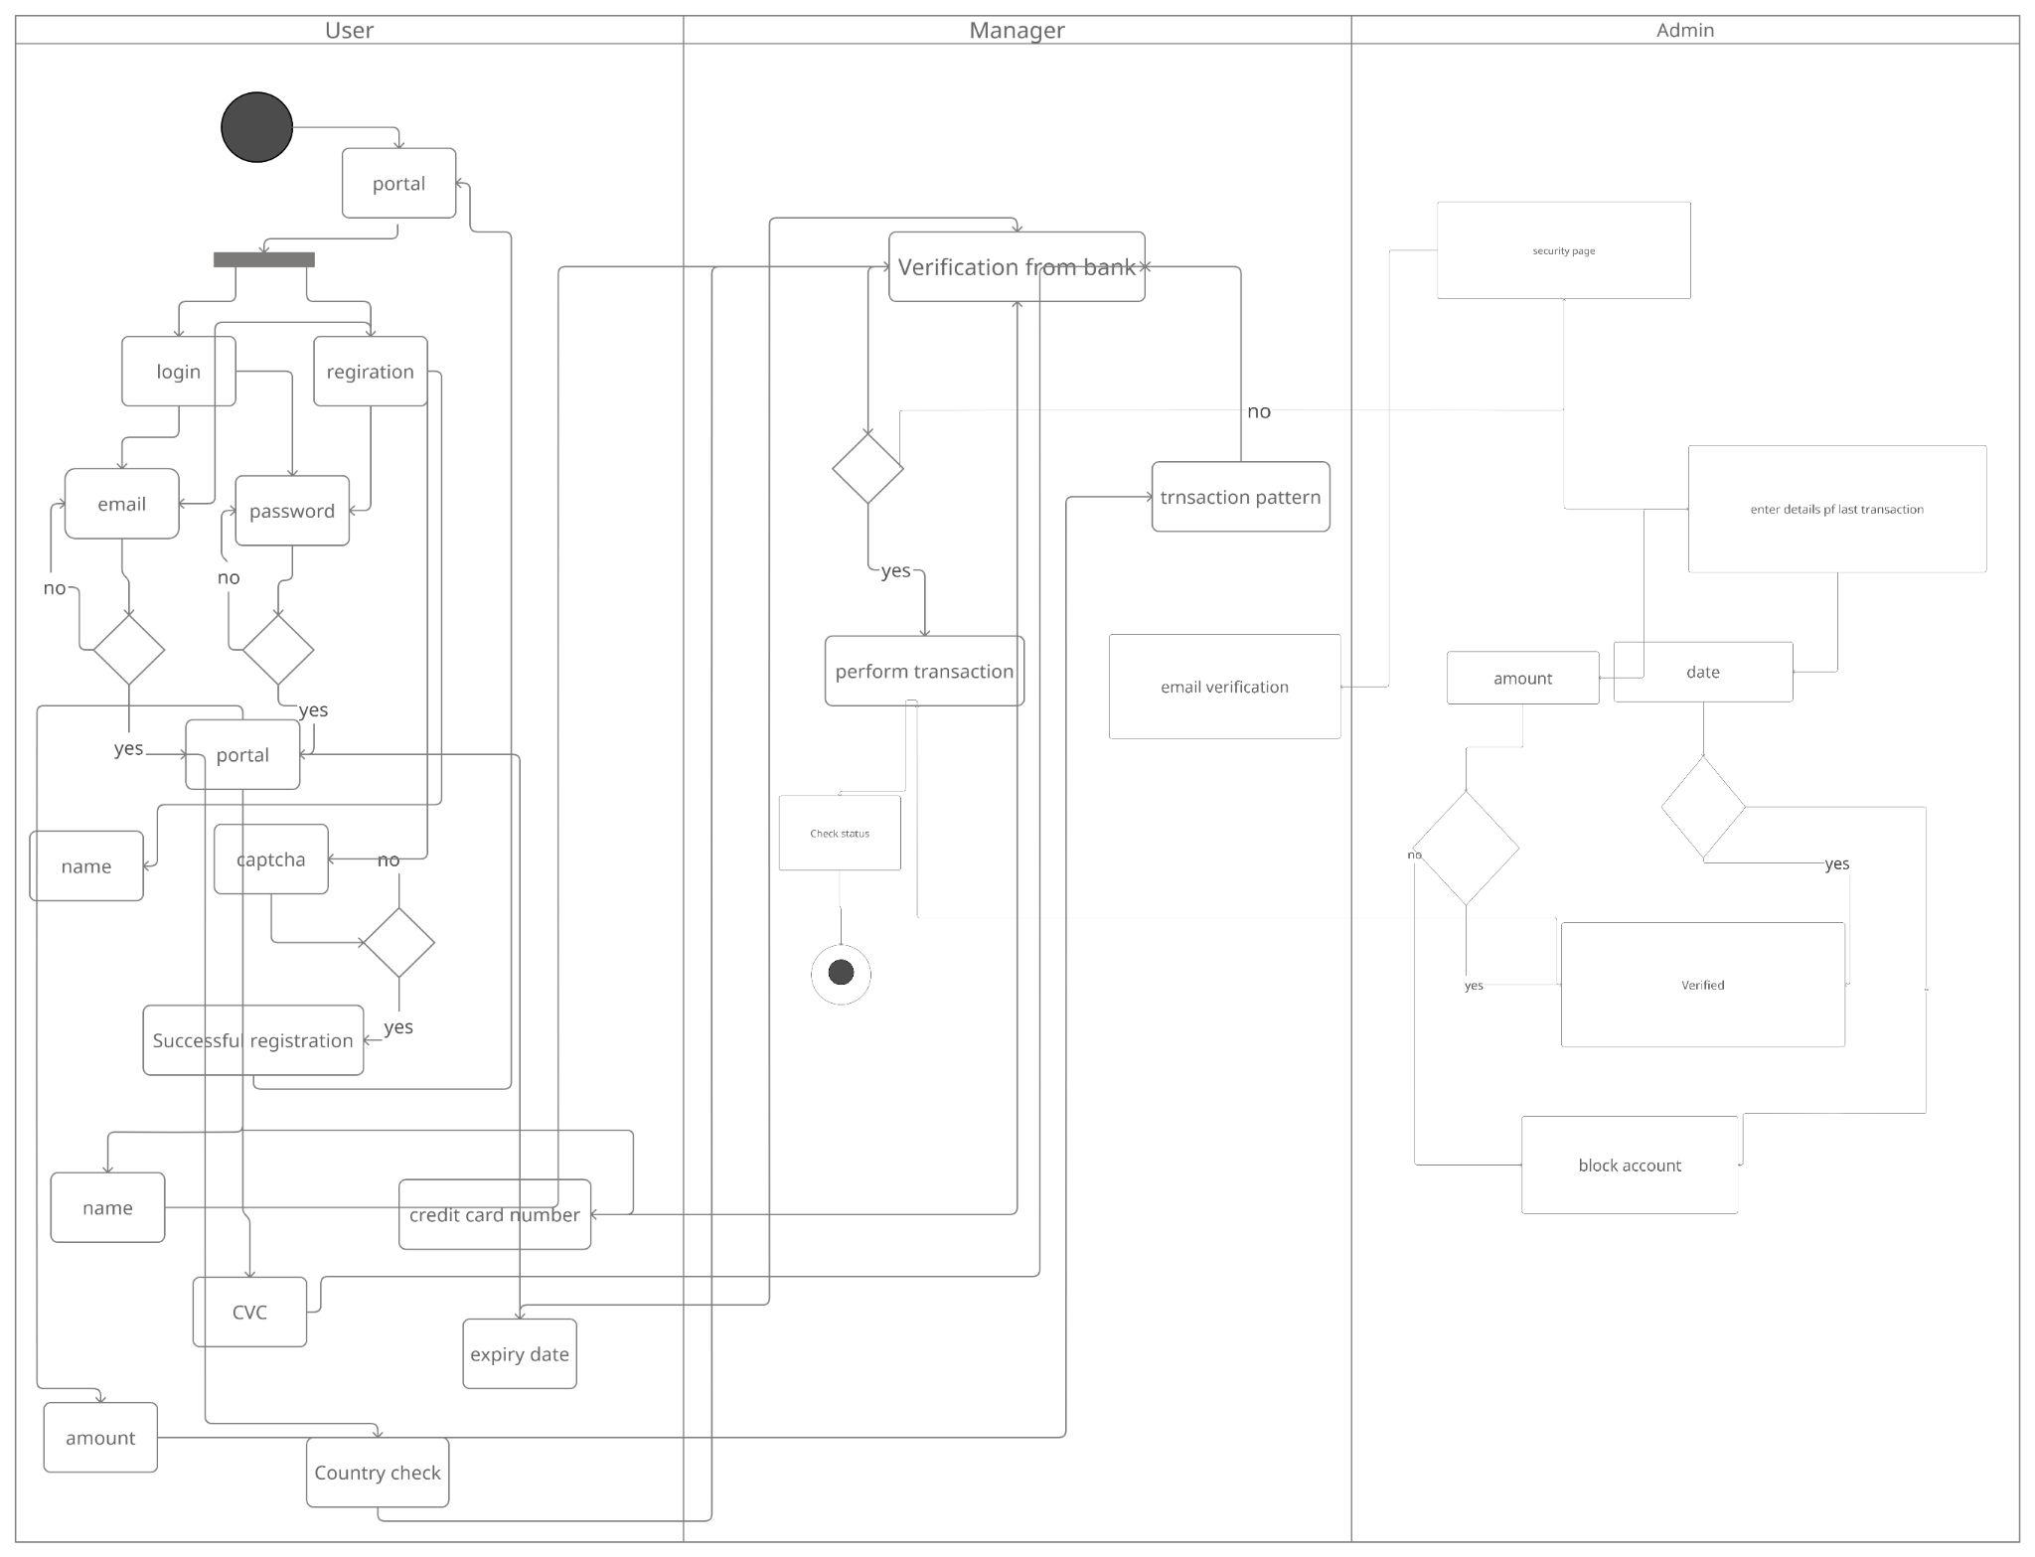

Package Diagrams:

Credit Card Fraud System:

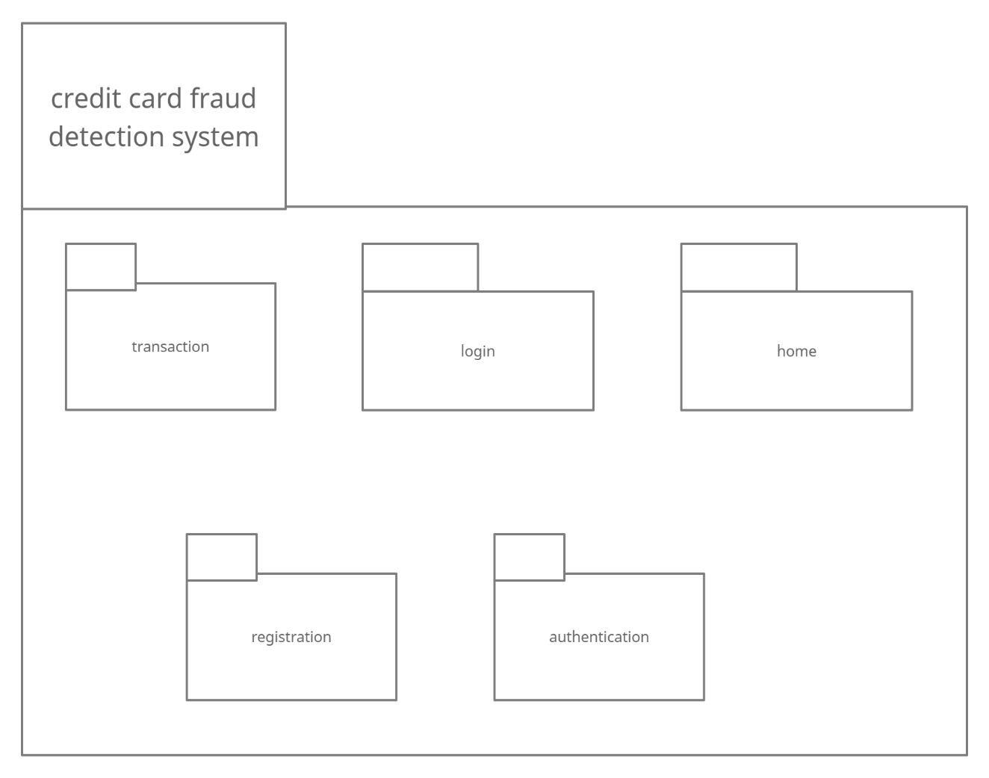

Home Package Diagram:
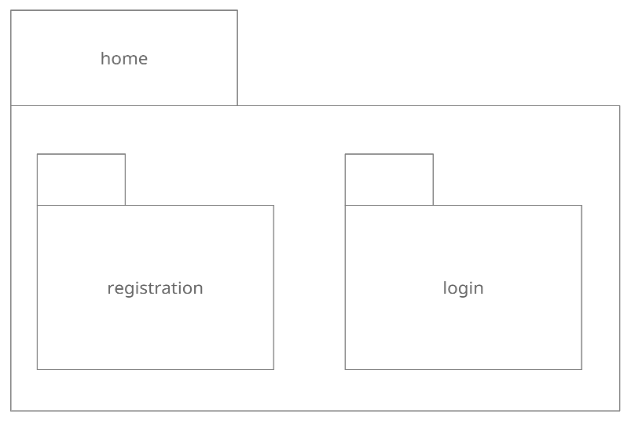

Login Package Diagram:
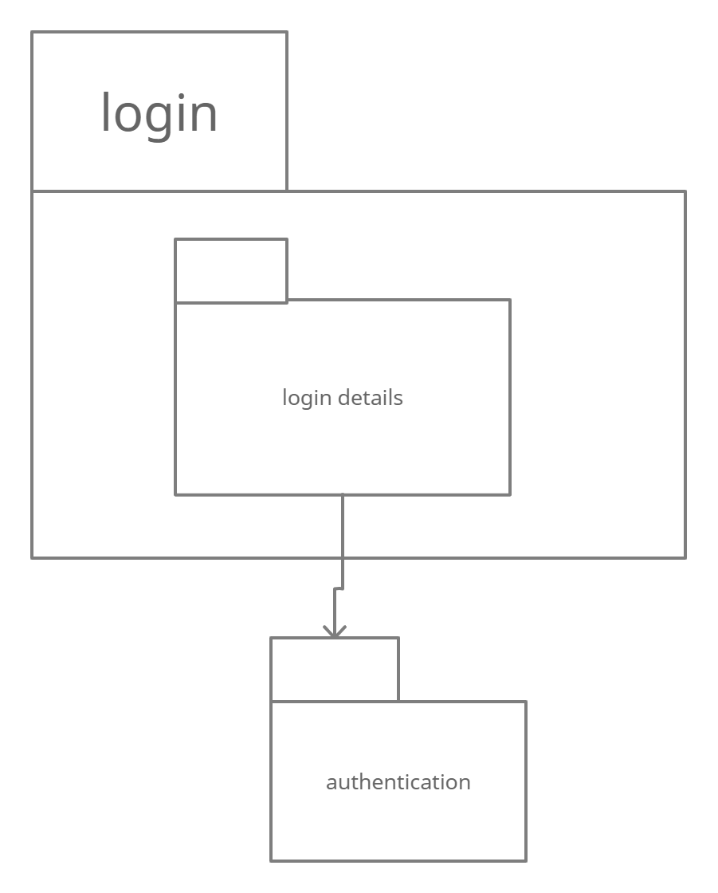

Registration Package Diagram:

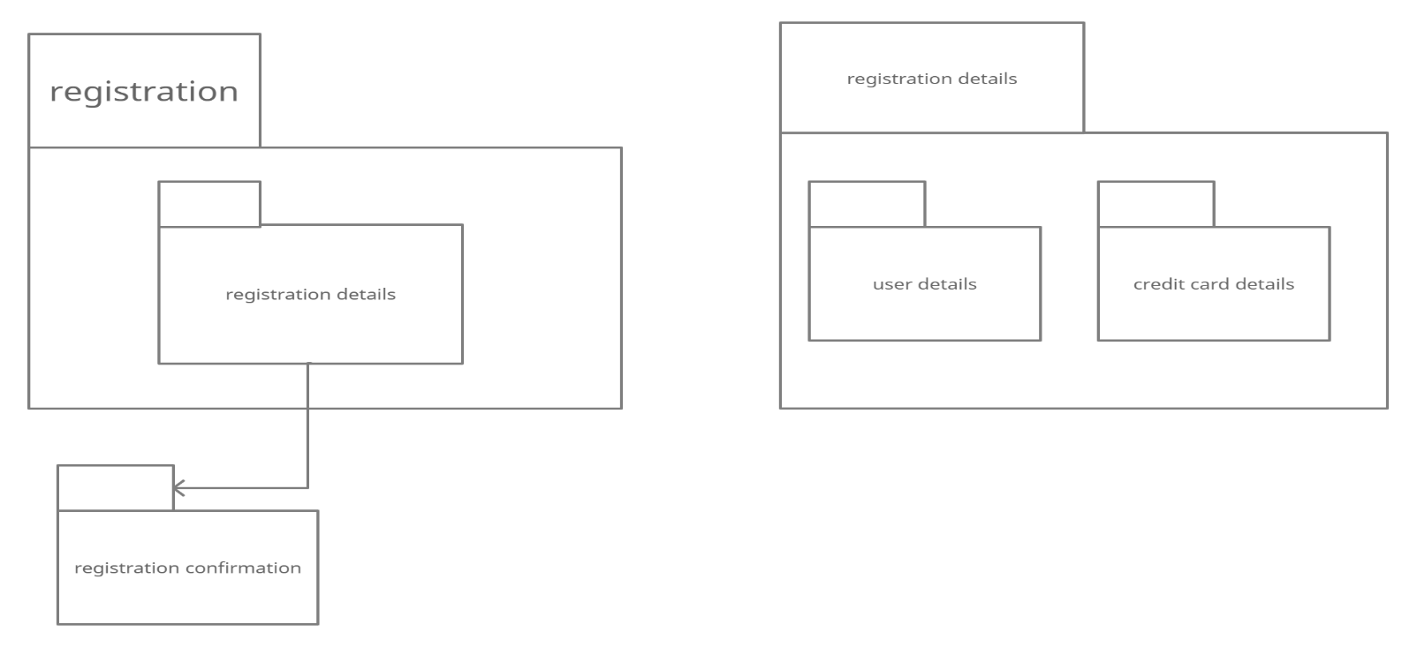

Authentication Package Diagram:

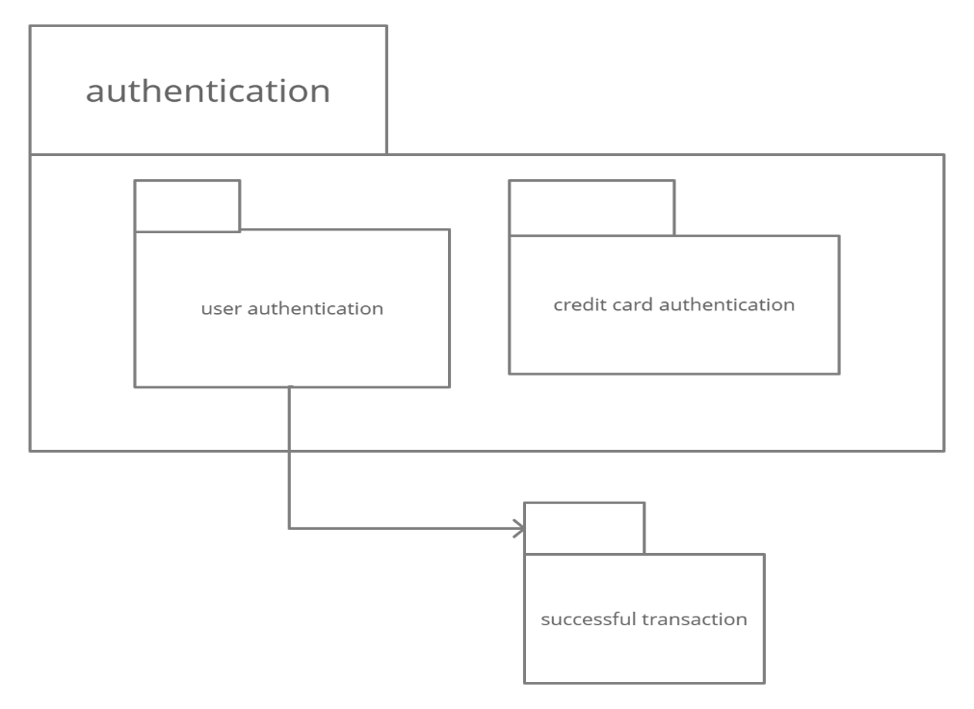

Transaction Package Diagram:

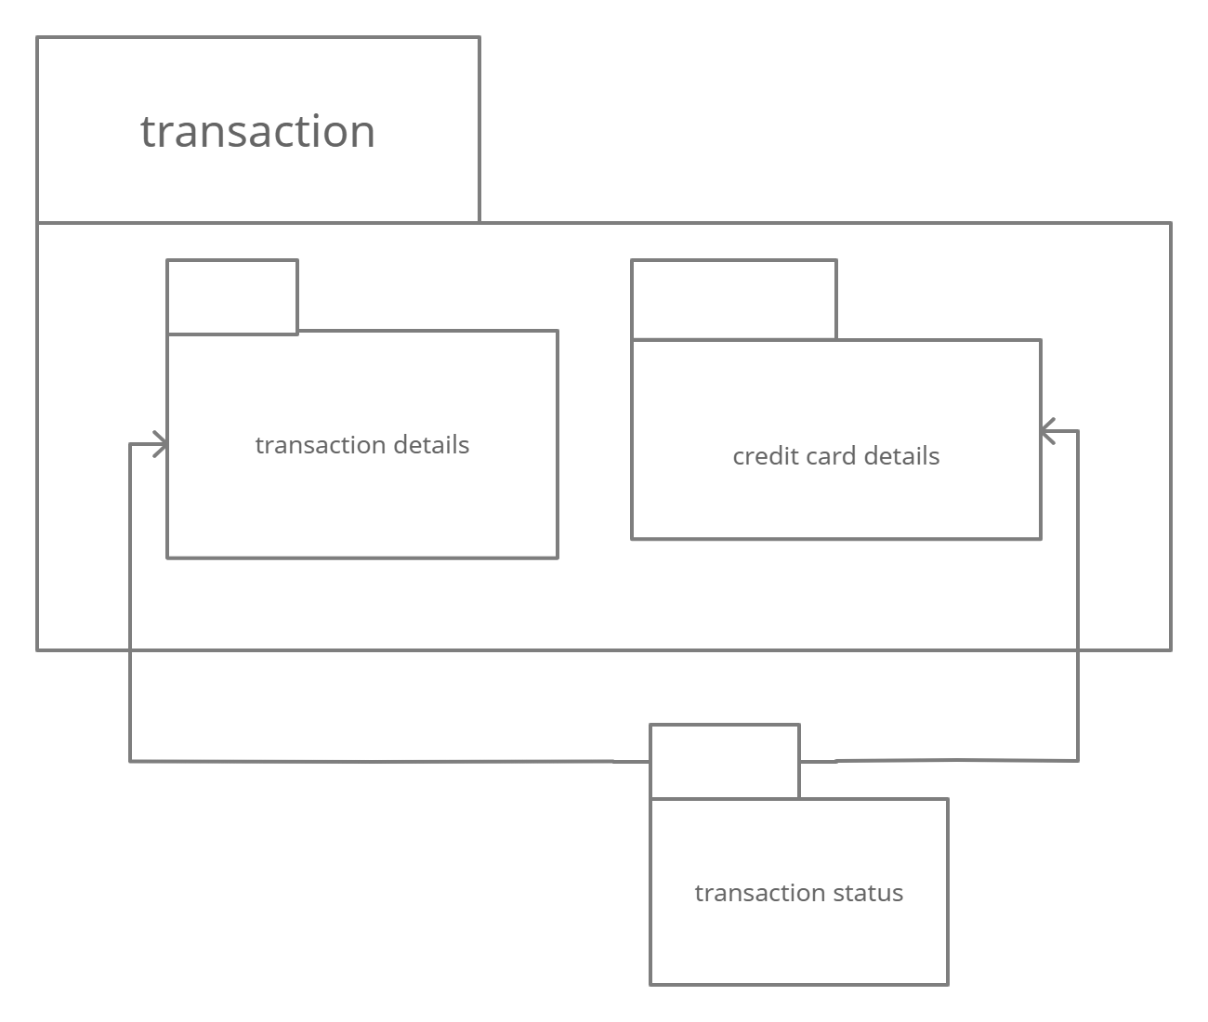

State Chart Diagram:

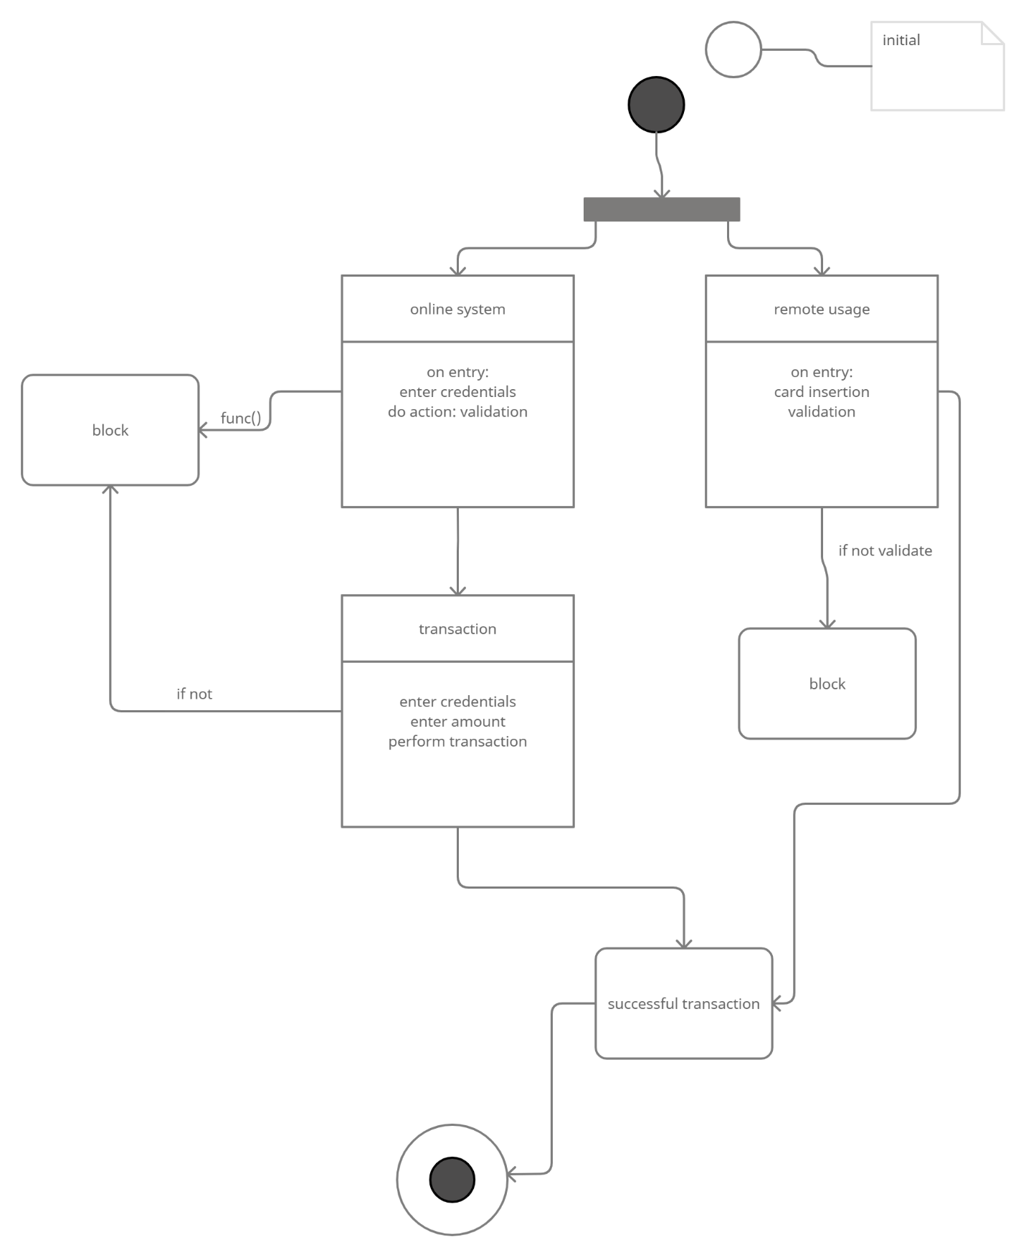

Design Class Diagram:

Architecture Level:
Architecture Level Design Class Diagram:
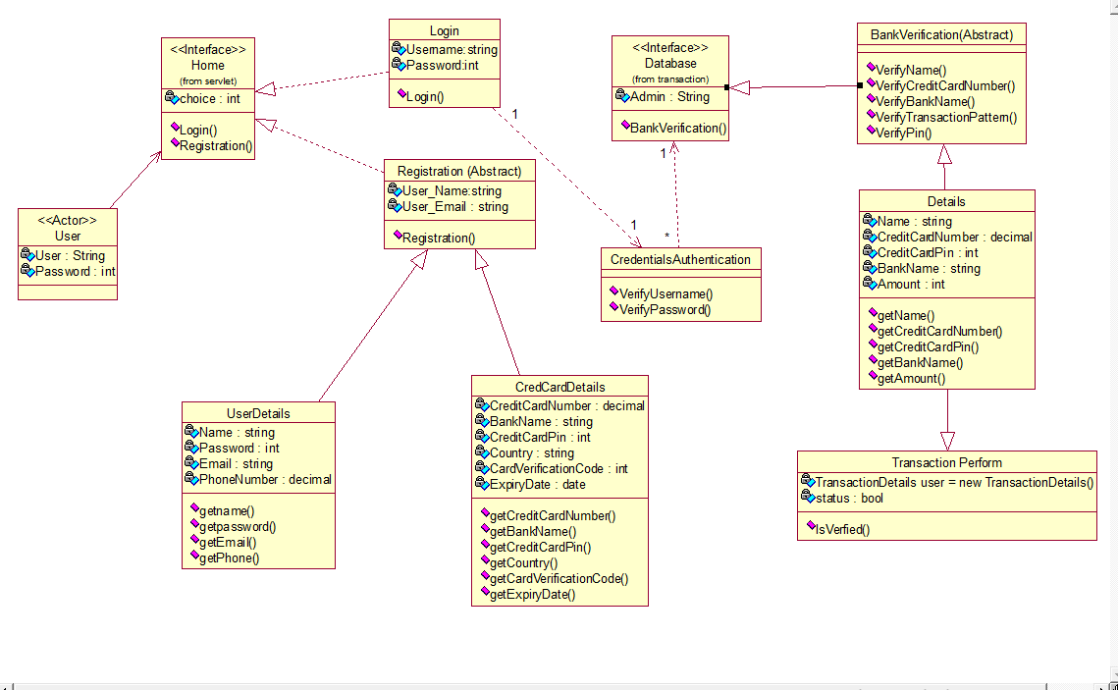

Business Level:

Business Level Design Class Diagram:
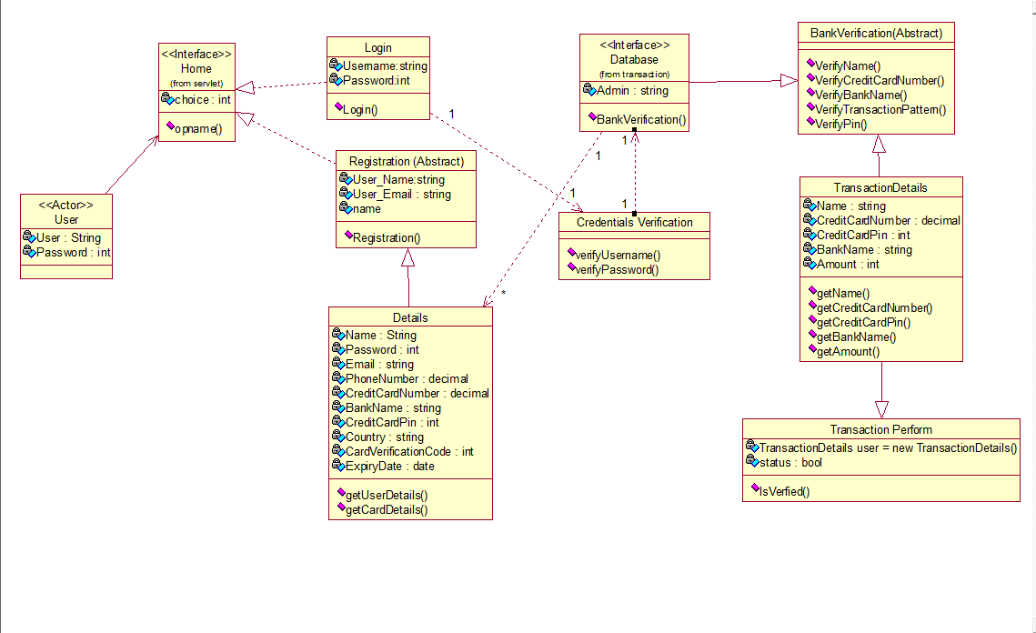

Sequence Diagram (SD):

Architecture Level:

Architecture Level Sequence Diagram:
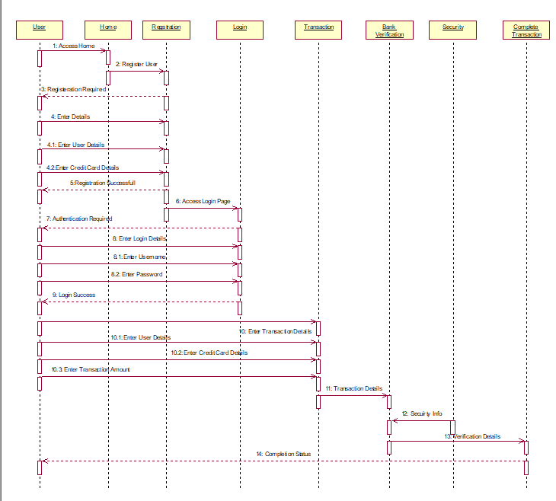

Business Level:

Business Level Sequence Diagram:
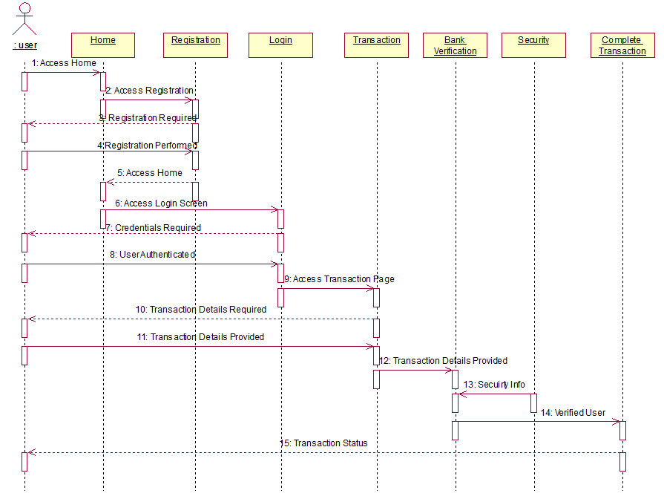

System Sequence Diagram (SSD):

1-SSD for use case Home and actor User:

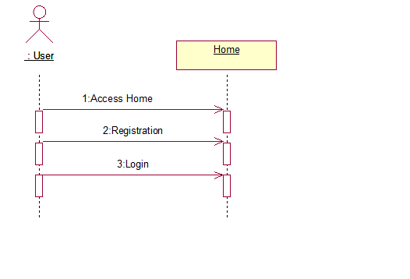

2-SSD for use case Home and actor Manager:

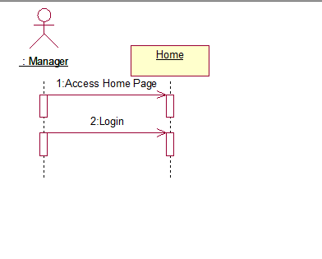

3-SSD for use case Registration and actor User:

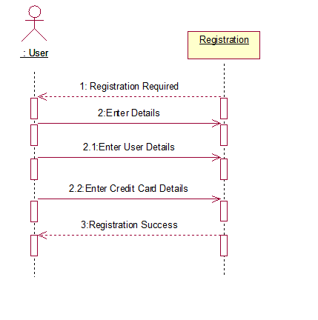

4-SSD for use case Registration and actor Manager:

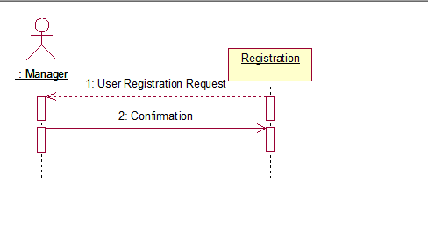

5-SSD for use case Login and actor User:

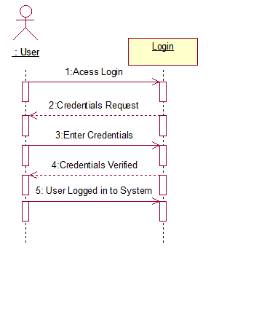

6-SSD for use case Authentication and actor Manager:

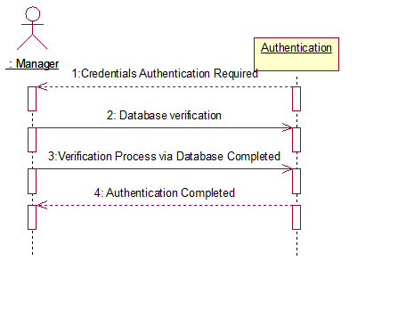

7-SSD for use case Transaction and actor User:

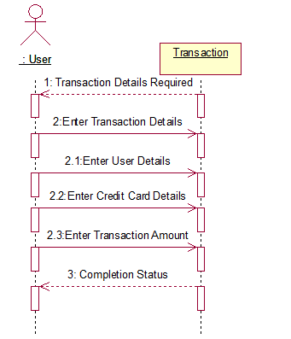

8-SSD for use case Transaction and actor Manager:

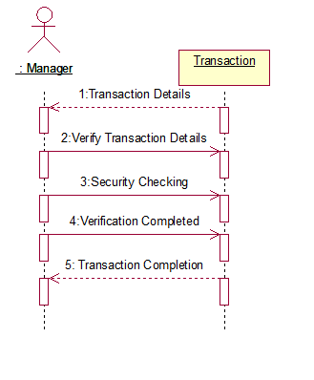

9-SSD for use case Transaction and actor Admin:

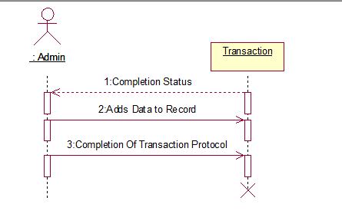

10-SSD for use case Security and actor User:

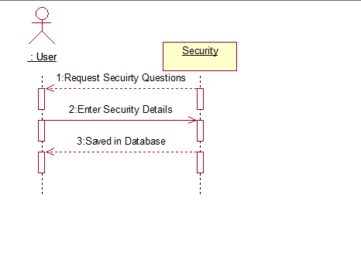

11-SSD for use case Security and actor Manager:

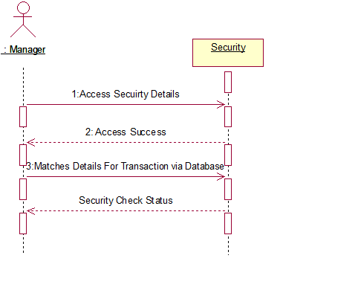

Collaboration Diagram

Architecture Level:

Architecture Level Collaboration Diagram:

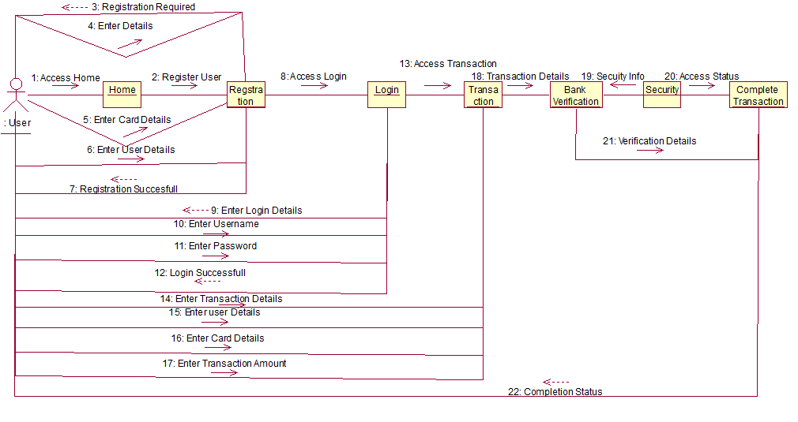

Business Level:

Business Level Collaboration Diagram:

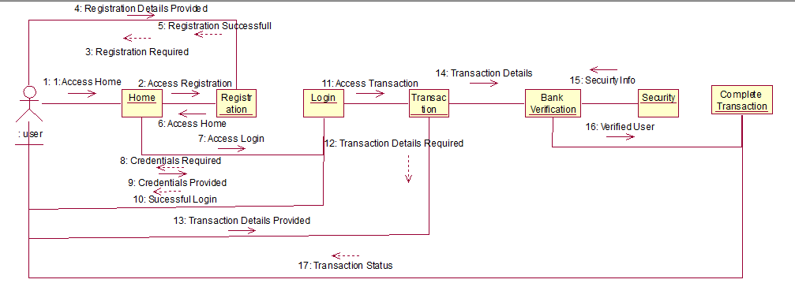

Risks

Friendly fraud:
Fraud committed by someone who actually knows the fraud victim. The victims in this type of fraud are usually well-known and can be family members, colleagues, neighbors, friends,
or acquaintances. Friendly frauds are usually difficult to detect as perpetrators have a fair idea about the victim’s personal information.

Bust-out fraud:
Bust-out fraud is an intentional fraud committed by those consumers who use all the available credit in a particular credit card and then skip the final payment.
In this kind of fraud, the consumer first builds good credit history, applies for a credit card, uses credit and makes regular payments, and finally exhausts all
the available credit (bust out) with no intention of paying it back.

Cloning:
Cloning card fraud is when criminals use details on the tracks on the magnetic strip of a credit card to create replica payment cards for committing fraud.

Malware:
Malware is malicious software designed to gain unauthorised access to a database or
network or operating system or computer without the consent of the user.

Skimming:
Skimming is the theft of payment card information using skimming devices while someone is performing legitimate transactions such as purchases at grocery stores, malls or any other places.

Phishing:
Phishing card fraud is when a criminal obtains a consumer’s financial or personal information by sending an authentic looking e-mail to them, which in turn lures them to a fake website
that looks almost similar to the victim’s institution.

Risks Mitigation

Artificial neural networks
An artificial neural network is an adaptive system that changes its structure based on internal and external information flowing through the network during the learning,
design and modeling phase. They are also used to find patterns in data and which are compared to historical fraud patterns for analysis. While neural networks are used to
find relationships and patterns, rules written by fraud specialists are applied to these relationships and patterns to either authorize or deny transactions.

Analytics
Analytics are used to evaluate the transaction activity for a portfolio. This evaluation is used to develop a set of rules for that portfolio to be applied in the authorization process.
Fraud specialists use findings from these evaluations to frame rules mainly targeting the transaction characteristics such as nature and location of spending, transaction speed like the
rate of card usage by the customer and other known patterns.

Alerts
Alerts are typically sent as an e-mail and/or SMS to cardholders but in some instances companies also make calls to inform the cardholder. Since a transaction must be successful in order
to generate an alert, alerts happen after the fact and do not prevent the fraudulent transaction. But alerts do help financial services institutions block payments to fraudulent merchants
claiming incorrect amounts and stop payments in cases where the transaction has happened without the knowledge of the consumer.

Customer-level views
Customer-level views identify the like spending patterns of different customers and group them together to monitor subsequent transactions. These methods are used to find suspicious
behavior by risk scoring those groups across an organization’s complete portfolio of products and brands. The fraud specialists can then take certain actions on the card usage of these
individuals based on the verification results. This helps financial services institutions check for inconsistencies in details submitted by consumers such as the same phone or addresses
across different applications.

Prototype (Wireframe)

Home Page:

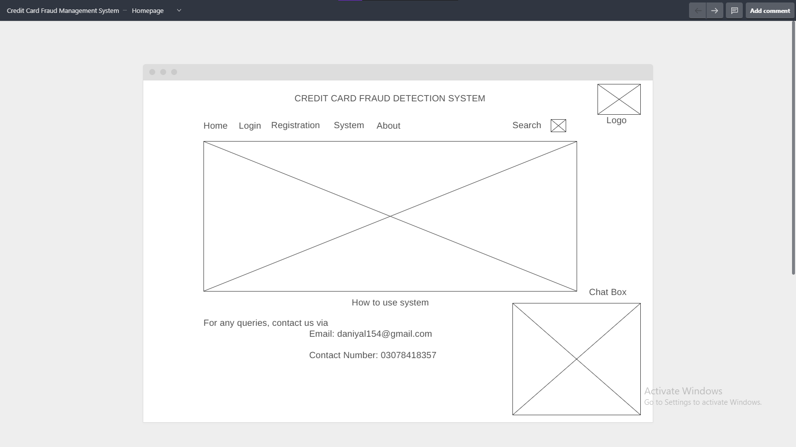

Registration Page:

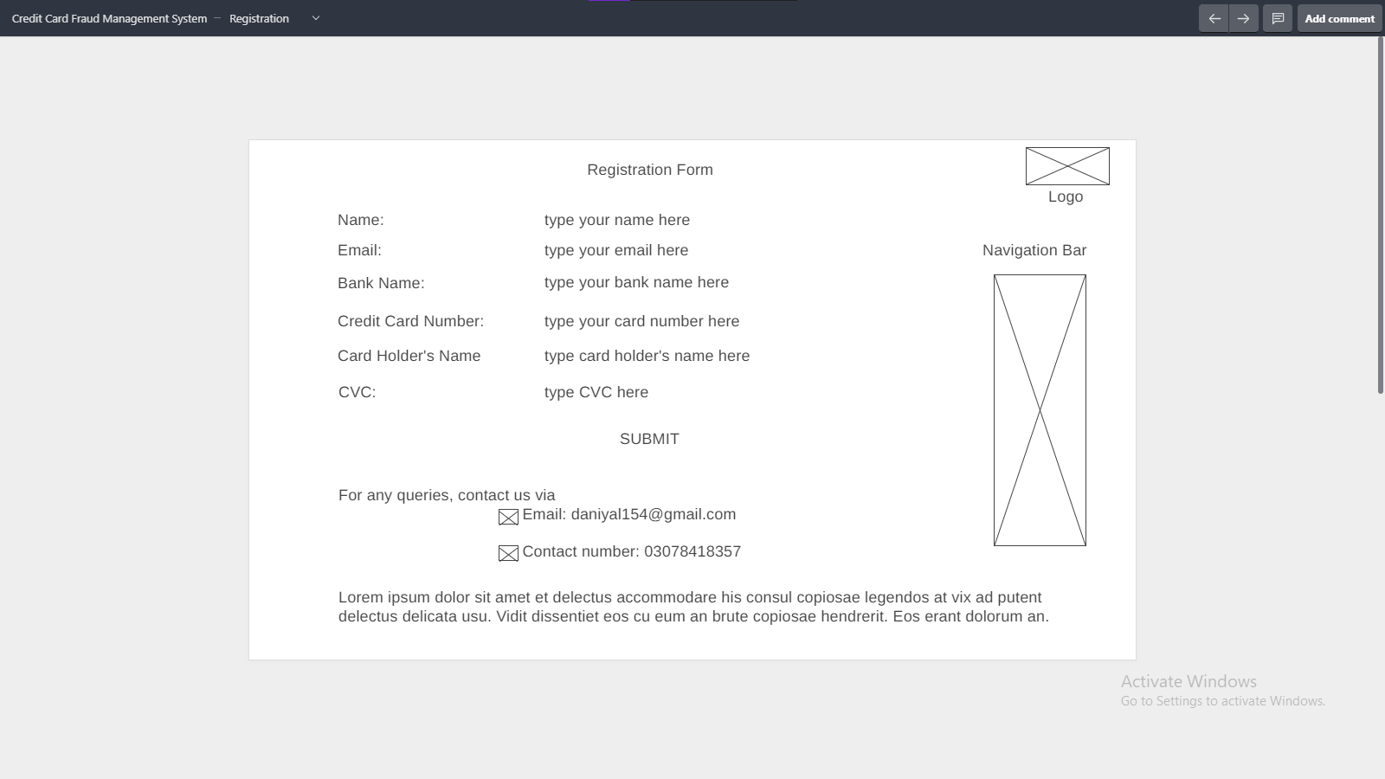

Login Page:

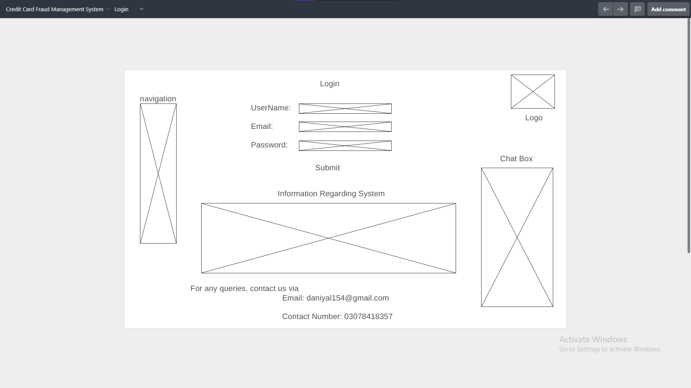

About Us:

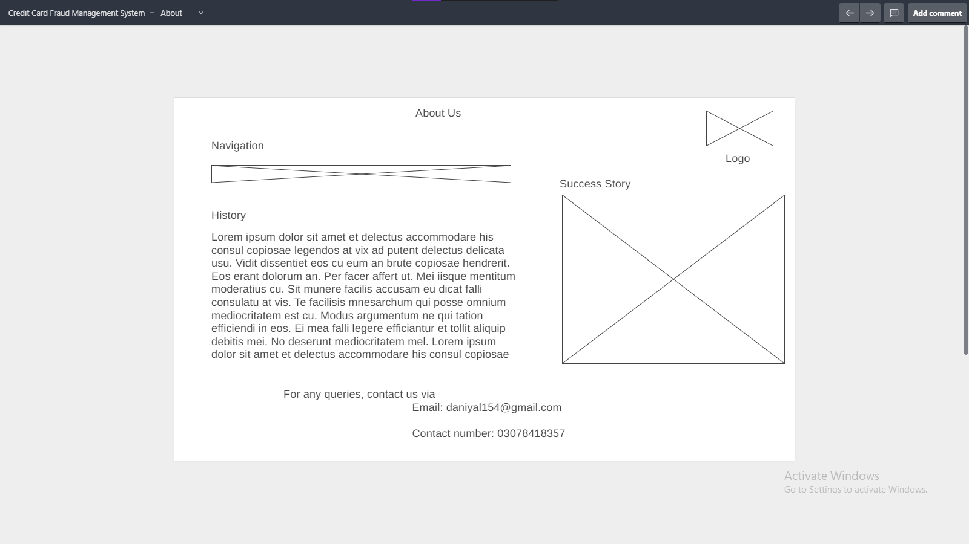

System Page:

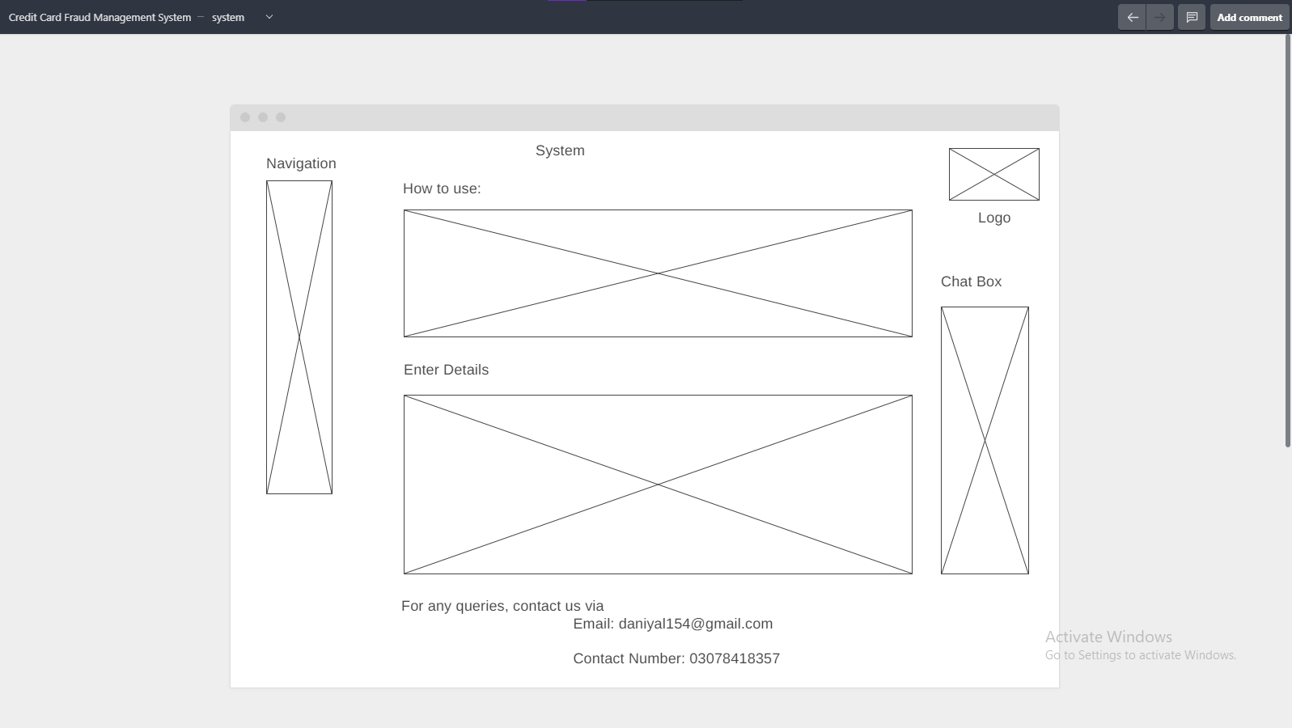

Use-Case Contracts:

Operation: EnterHome(int choice)
Cross Reference: Home
Pre-Condition: User opens our Credit Card Fraud Detection System and would enter a choice to login or register and home would take him to respective screen.
Post Condition: User will be able to Login or Register to his account for further procedure.

Operation: Register()

Cross Reference: Registration
Pre-Condition: User can access Register Page via Home. Post Condition: Now the user will be registered, and he can proceed with the system.
Post-Condition: User will successfully register himself into Detection System.

Operation: Details(string name, string bankname , int CVC, int PhoneNumber, string email, decimal CardNumber)
Cross Reference: Registration
Pre-Condition: User access details section after accessing registration through Home Page.He can write details now.
Post Condition: After registration, he is allowed to login as a registered user.

Operation: userDetails(Details user)
Cross Reference: Registration
Pre-Condition: User would access registration page to enter his details
Post Condition: His details are saved successfully

Operation: cardDetails(Details card)
Cross Reference: registration
Pre-Condition: user would access registration page to enter card details
Post Condition: Card details are saved successfully

Operation: login(string password, string username,string email)
Cross Reference: Login
Pre-Condition: User access login page through home and would enter credentials to login to his account.
Post-Condition: After Logging in user can perform transaction.

Operation: credentialsAuthentication(int choice)
Cross Reference: authentication
Pre-Condition: user would enter home to login and would enter credentials to verify from database
Post Condition: user will be logged into system, if credentials will be verified, user will be able to proceed else he will have to provide valid information to proceed through the system

Operation: AccessTransaction(Details user, Details card)
Cross Reference: Transaction
Pre-Condition: User would access Transaction after Logging into system.So that he can perform transaction.
Post Condition: If there is no fraud detected in transaction pattern and security check, transaction will be done successfully else after 3 unsuccessful attempts,the card’s geographical location and amount will be checked and these will be compared to previous transactions.If the system will detect any fraud, the user will be notified and the card will get blocked.

Operation:TransactionDetails()
Cross Reference: Transaction
Pre-Condition: User accesss transaction page after Logging into system. He would then Enter card owner details, card details, amount to proceed further.
Post Condition: all the details will be sent for transaction verification. After verification transaction is completed

Operation:bankVerification(Details Userdetails, Details Carddetails , TransactionDetails details)
Cross Reference: Transaction
Pre-Condition: User access transaction page after Logging into system and enters his details. His details are sent to bank for verification to proceed for transaction.
Post Condition: Bank will verify whether the user is associated with bank or not, and if verified, he can proceed with his transaction else he will be asked to enter correct information

Operation: securityCheck(string []questions)
Cross Reference: Security
Pre-Condition: when user will enter details wrong for the third time he will be directed to a security page.
Post Condition: it will ask user security questions which he provided during registration process and if user will be able these questions correctly, he will be able to proceed else his card will be blocked.

Operation:Transaction Status(bool check)
Cross Reference: Transaction
Pre-Condition: If there was no fraud detected, transaction would be done successfully and status will return true,else transaction wolud be failed.
Post Condition: If there was no fraud detected, user will be able to transfer the amount and transaction status will be true, else transaction status will be false.

Github Repository Link:

https://github.com/Nimraahh/Credit-Card-Fraud-Detection-System

WireFrame Link:

https://wireframe.cc/pro/pp/b20909faf503722?fbclid=IwAR3832HBDjcU9z1UfHidzmIWuxmx9YRZoDSXf3sb5ZpmS6Ks-x8tkrBE90A

Glossary:
CVC: Card Verification code

Predictive Analysis: Pre-analysis (before fraud)
Transaction Amount: the aggregate value of all of the issued

